

MARANDA 2025 KCSE PREDICTION
EXPECTED EXAM 1
ELECTRICITY
448/1
PAPER 1 (Theory)
TIME: 2½ HOURS

NAME……………………………………………………………………………………..
SCHOOL……………………………………………… SIGN………………………..
INDEX NO……………………………………………. ADM NO……………………

Kenya Certificate of Secondary Education.

INSTRUCTIONS TO CANDIDATES
- Write your Name, Index number and Class in spaces provided
- Candidates should have the following for this examination
Drawing instruments
Scientific calculator
- This paper consists of two sections: A and B.
- Attempt ALL questions in section A and any FOUR in section B.
- All dimensions are in millimeters unless stated other wise

For Examiner’s use only
Section | Questions | Maximum Score | Candidate’s Score
A | 1-10 | 48
B | 11 | 13
 | 12 | 13
 | 13 | 13
 | 14 | 13
 | 15 | 13

SECTION A (48 marks)
(Attempt all questions in this section)
- Explain the significance of using only one hand when working on high voltage system (2 marks)
…………………………………………………………………………………………………………
…………………………………………………………………………………………………………
…………………………………………………………………………………………………………

- a) Define each of the following terms: (3 marks)
- semiconductor
…………………………………………………………………………………………………………
…………………………………………………………………………………………………………
- intrinsic semiconductor
…………………………………………………………………………………………………………
…………………………………………………………………………………………………………
- extrinsic semiconductor
…………………………………………………………………………………………………………
…………………………………………………………………………………………………………

b) Draw and label voltage versus current characteristics curve for a P-N junction in its forward and reverse modes (3 marks)

- a) A 5kΩ linear potentiometer has 6V source connected across its end terminals
- Determine the range of output voltage of the potentiometer (1 mark)
…………………………………………………………………………………………………………
…………………………………………………………………………………………………………
…………………………………………………………………………………………………………

- Calculate the two possible output voltages when the potentiometer is in its three-quarter position (2 marks)
…………………………………………………………………………………………………………
…………………………………………………………………………………………………………
…………………………………………………………………………………………………………

b) An emf of 120V causes a current of 3A to flow in a circuit. Calculate the energy supplied by the source in 12 seconds (2 marks)
…………………………………………………………………………………………………………
…………………………………………………………………………………………………………
…………………………………………………………………………………………………………
…………………………………………………………………………………………………………

- a) Outline two differences between a permanent magnet and an electromagnet (2 marks)
…………………………………………………………………………………………………………
…………………………………………………………………………………………………………
…………………………………………………………………………………………………………
…………………………………………………………………………………………………………

b) State and explain two properties of a good conductor (2 marks)
…………………………………………………………………………………………………………
…………………………………………………………………………………………………………
…………………………………………………………………………………………………………
…………………………………………………………………………………………………………

- a) List four electrical measurements that can be taken using a cathode ray oscilloscope (2 marks)
…………………………………………………………………………………………………………
…………………………………………………………………………………………………………
…………………………………………………………………………………………………………
…………………………………………………………………………………………………………

b) A moving coil meter gives a full scale deflection for a current of 100mA and has a resistance of 5Ω. Determine the value of the resistor used so that the meter can measure a current of 1.0A at full scale deflection. (3 marks)
…………………………………………………………………………………………………………
…………………………………………………………………………………………………………
…………………………………………………………………………………………………………
…………………………………………………………………………………………………………
…………………………………………………………………………………………………………

- a) Draw the current discharge curve of a capacitor (2 marks)

b) Outline how insulation resistance test can be carried out between two conductors (5 marks)
…………………………………………………………………………………………………………
…………………………………………………………………………………………………………
…………………………………………………………………………………………………………
…………………………………………………………………………………………………………
…………………………………………………………………………………………………………
…………………………………………………………………………………………………………
…………………………………………………………………………………………………………

- a) Name the logic gate shown in Figure 1 (1 mark)
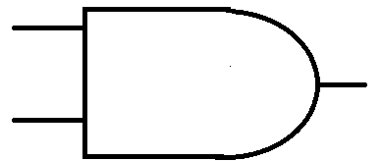
Figure 1
Name…………………………………………..
b) Complete the truth table of the OR gate (2 marks)
INPUT 1 | INPUT 2 | OUTPUT
0 | 0
0 | 1
1 | 0
1 | 1

c) Perform each of the following number conversions (4 marks)
- 101010₂ to decimal
…………………………………………………………………………………………………………
…………………………………………………………………………………………………………
…………………………………………………………………………………………………………

- 23₁₀ to binary
…………………………………………………………………………………………………………
…………………………………………………………………………………………………………
…………………………………………………………………………………………………………

- a) Name four sources of electricity in Kenya (2 marks)
…………………………………………………………………………………………………………
…………………………………………………………………………………………………………
…………………………………………………………………………………………………………
…………………………………………………………………………………………………………

b) State one possible cause and remedy for each of the following electric motor faults (4 marks)
- Motor connected to the supply but will not start
…………………………………………………………………………………………………………
…………………………………………………………………………………………………………
…………………………………………………………………………………………………………

- Motor overheats on load
…………………………………………………………………………………………………………
…………………………………………………………………………………………………………
…………………………………………………………………………………………………………

- Draw wiring diagram of a 12V electric bell controlled by two switches from a 240V mains supply (4 marks)

- a) Define entrepreneur (1 mark)
…………………………………………………………………………………………………………
…………………………………………………………………………………………………………
b) List two business opportunities in the field of electricity (1 mark)
…………………………………………………………………………………………………………
…………………………………………………………………………………………………………
…………………………………………………………………………………………………………
SECTION B (52 marks)
Answer any four questions from this section in the spaces provided
- a) State three variables which determine resonance condition in an RLC circuit (3 marks)
b) A series circuit consisting of a 0.1µF capacitor and a 25µH, 20Ω coil is connected across a 10V a.c supply. Calculate the following: (10 marks)
- Resonant frequency
- Supply current at resonance
- Voltage across the capacitor at resonance
- With the aid of a labelled diagram, show the construction and describe the operation of a moving coil permanent magnet type instrument (13 marks)

- a) Explain the term ideal transformer (3 marks)
b) A transformer which has a primary winding resistance of 1Ω and a secondary winding resistance of 0.1Ω is connected to a 10Ω load. if the primary current is 0.5A and secondary is 5A, calculate: (6 marks)
- Load power
- Copper losses
c) If the transformer in (b) has a core loss of 5W, calculate the efficiency of the transformer (4 marks)
- The transistor in the circuit shown in Figure 2 below is biased to supply the relay with 100mA. the dc current gain, β, of the transistor is 50 and the forward base-emitter voltage, V_{BE} is 0.7V
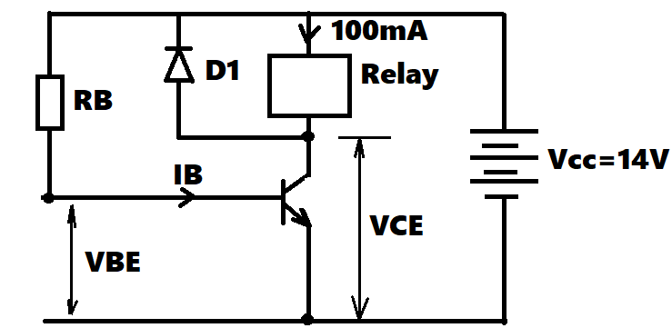

- If the voltage drop across the relay is 12V, calculate the: (11 marks)
- Base current I_{B}
- Emitter current I_{E}
- Voltage between collector and emitter V_{CE}
- The base resistance R_{B}
- Explain the function of diode D1 in the circuit (2 marks)

- Figure 3 shows three views of an object drawn in first angle orthographic projection. make isometric drawing of the object taking A as the closest point (13 marks)
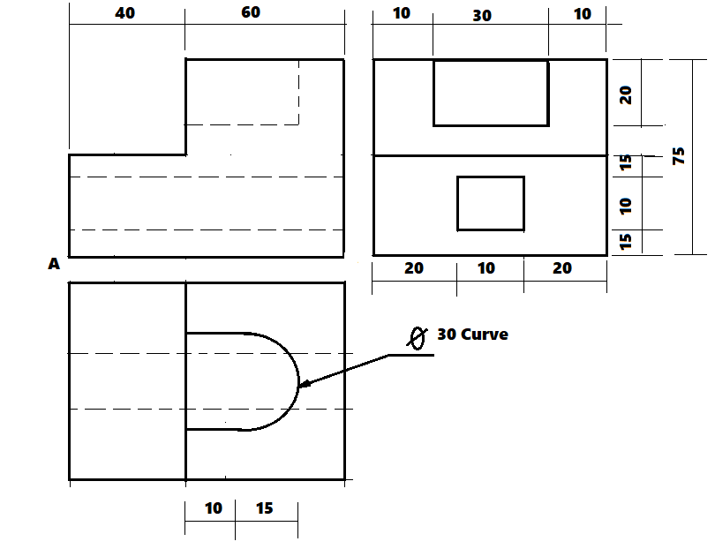
Figure 3

